**PROGRAM(BCD TO HEX):**

Data Segment

bcd dw 25h

hex dw ?

Data Ends

Code Segment

Assume Cs:Code,Ds:Data

start:

mov ax,data

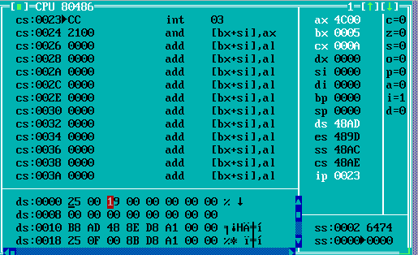 mov ds,ax

mov ax,bcd

and ax,000fh

mov bx,ax

mov ax,bcd

and ax,00f0h

mov cl,04h

ror al,cl

mov cl,0Ah

mul cl

add ax,bx

mov hex,ax

mov ax,4c00h

int 03h

code ends

end start

**PROGRAM(HEX TO BCD):**

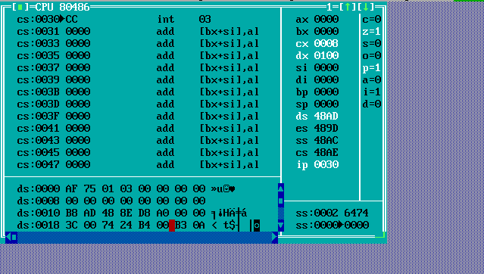DATA SEGMENT  
HEX DB 0AFH  
BCD DW 0  
CNT DB 0  
DATA ENDS  
CODE SEGMENT  
ASSUME CS:CODE,DS:DATA  
START:  
MOV AX,DATA  
MOV DS,AX  
MOV AL,HEX  
CMP AL,00  
JZ LAST  
  
LOOP1:  
MOV AH,00  
MOV BL,0AH  
DIV BL  
MOV DH,00  
MOV DL,AH  
MOV BL,AL  
MOV AL,04  
MUL CNT  
MOV CL,AL  
ROL DX,CL  
OR BCD,DX  
MOV AL,BL  
INC CNT  
CMP AL,0  
JNZ LOOP1  
LAST:INT 3  
CODE ENDS  
END START  
END